Dan Batsie
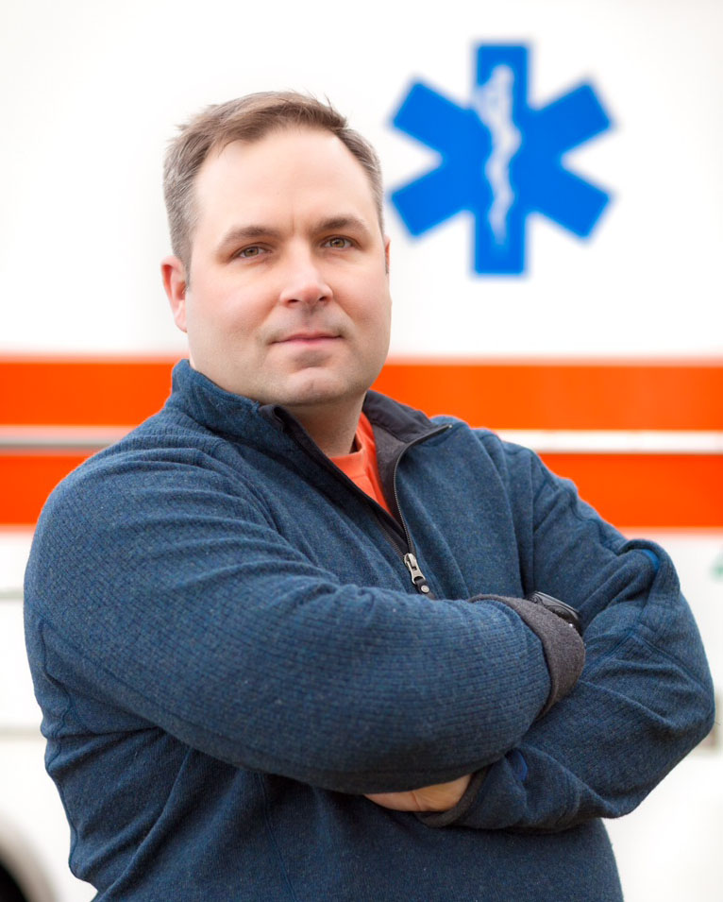

Dan Batsie has been involved in EMS for 23 years and has been a paramedic for 18 years.
He is currently the Director of Education for Atlantic Partners EMS. Atlantic Partners EMS is a regional resource office for Maine Emergency Medical Services. In the role of Education Director, Dan oversees all licensure and continuing education programs. He also serves as program coordinator for both the Eastern Maine Community College and Kennebec Valley Community College paramedic programs.
Dan has been teaching for 18 years and has experience in instructing both prehospital and hospital personnel. In addition to holding numerous instructor certifications from both state and national organizations, Dan serves as chair of the state education committee for Maine and as a member of the National Association of EMTs Education Committee.
In addition to his administrative duties, Dan has continued to instruct in both the Eastern Maine and Kennebec Valley Paramedic programs. He has been a visiting adjunct instructor at the National Ambulance Training School in Dublin Ireland and instructed medical providers in Port of Spain, Trinidad and Santo Domingo, Dominican Republic. Dan has also been a guest medical instructor for the 75th Ranger Regiment at Fort Benning and for both the East and West Coast Squadrons of the Air Force Para Rescue.
Since 2007, Dan has also been an EMS textbook author with Brady/Pearson Publications. He has contributed to textbooks at both the First Responder and EMT level and his first primary authored paramedic text is scheduled for release this summer.

