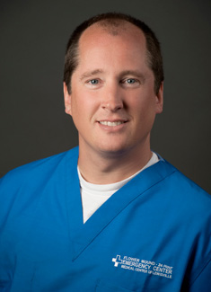

Bio: Dr. Carl Menckhoff

Dr. Menckhoff graduated from George Washington University medical school in 1994. He completed his Emergency Medicine Residency at Loma Linda University Medical Center in 1997 and then joined the faculty at UTSW Parkland Memorial Hospital where he was assistant professor and assistant residency director until 2000.

He spent 9 years at Medical College of Georgia in Augusta, GA where he was associate professor and Emergency Medicine Residency Director. He moved back to Dallas in 2009 where he currently serves as Regional Ultrasound Director for Questcare Partners as well as Medical Director and Chairman of the emergency departments at Medical Center of Lewisville and Flower Mound Emergency Center.

Dr. Menckhoff has participated in multiple international missions, including projects in Papua New Guinea, Honduras, Guatemala, Mexico, Cuba and the Dominican Republic.

